Wesham Town Council Monthly Meeting to be held on
Tuesday, 16th January 2024
at 7.30pm in the Committee Room, Wesham Community Centre.

AGENDA

APOLOGIES: Cllrs P Desmond

CODE OF CONDUCT AND STANDING ORDERS
Members are reminded of the standard of conduct they must adhere to during Town Council meetings.

DECLARATION OF INTERESTS:
Members are reminded that any direct or indirect pecuniary or other interests should be declared as required by the Council’s Code of Conduct for Members.

24/001 APPROVAL OF THE MINUTES
OF THE COUNCIL MEETING HELD 12th December 2023
24/002 MATTERS ARISING – any item not covered by agenda or action list

24/003 POLICING ISSUES -
- Crime Reports – police.org.uk website > area > PR4 3DR (WCC postcode)
- Policing Issues – to discuss any items raised by Councillors

Update on Policing information – Cllr Doug Nowell

24/004 PLANNING -
- Planning Applications –

24/001 – 15 Belgrave Ave, Wesham

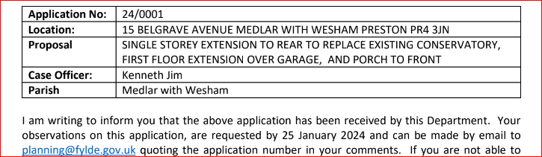

???? Any Mill Farm items/updates ????

24/005 PLAYING FIELDS and OPEN SPACES – any urgent items?

24/006 HIGHWAYS AND RAILWAYS – any urgent items?
Parking issues @ Meadow Park
24/007 GOVERNANCE, FINANCE AND INSURANCE

Accounts payable and income received report –

WTC Monthly summary – Nov 2023

Unity Trust Bank Transfer update

Accident and Incident Reporting – none

24/008 EVENTS
Update from LW & SH
24/009 HUMAN RESOURCES
- HR sub-committee – update?
- WTC Town Clerk
- WCC Manager
- WCC Cleaner

24/010 WESHAM COMMUNITY CENTRE - Note: BAU @ WCC meetings
- Any urgent updates
- Heating issues ?

23/011 OTHER
- LALC membership
- Website
- Actions

DATE OF NEXT WTC Monthly MEETINGs: 16th Jan 2024

Date | Meeting
16th Jan 2024 | WTC Monthly meeting
30th Jan 2024 | Finance Meeting ( 2nd Precept discussion)
6th Feb 2024 | WCC meeting
8th or 13th Feb 2024 | Town Clerk interviews
20th Feb 2024 | WTC Monthly meeting
19th Mar 2024 | WTC Monthly meeting
Angela Hunter Date: 6th January 2024

